
Equivalent Clearcut Area Tool
A Reference Guide
ECA percentages represent the amount of disturbance to a watershed due to fire, logging and other factors and there is legal guidelines limiting logging beyond a certain percentage.
GIS Contacts: Jennifer Marr jennifer.marr@gov.bc.ca, Alex Carr alex.carr@gov.bc.ca

Background

Generally, the threshold for when a hydrologist is called by BCTS is an ECA of 20%, except in community watersheds or for watersheds feeding a community well, then it’s 10%. This tool estimates ECA - a truly accurate assessment is based on factors outside of GIS capability such as soil type, permeability and depth and can only be determined by a hydrologist on-site.

In early 2024, the Woodlands Manager for the Cariboo Chilcotin business area requested a report comparing our ECA method (see ComparisonofAllMethods.xlsx) to the Foresite deliverables within their annual Landbase Assessment Report. This revealed holes and opportunities for improvement with the BCTS methodology.

The mandate of the BCTS GIS Analytical team is to automate (or overtake) analyses that the Business Areas currently contract out. Thus, the scope of this project is to modify the existing script to match or better the deliverable from Foresite.

preliminary Steps

You will need to create the watershed boundaries and clip a DEM to the watershed boundary before opening the ECA tool, as these will both be inputs. The watershed boundary is typically either:
- sourced from the freshwater atlas WHSE_BASEMAPPING.FWA_WATERSHED_GROUPS_POLY
- provided by the requestor
- created using LiDAR data using the following process //bctsdata/data/north_root/Library/Scripts/ECA/Documentation/watershed_flowchart.html

quick and dirty instructions

- Open a blank ArcGIS Pro Project
- Open the ECA Toolbox here:
\\bctsdata\data\north_root\Library\Scripts\ECA\Toolbox\ECA Tools.tbx
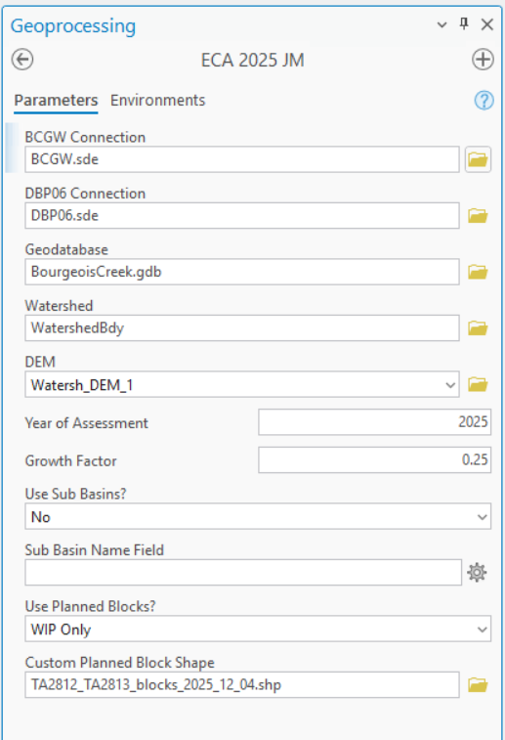
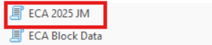
- Drag in the GDB connections, it may prompt you for a password
- Create and point to a blank geodatabase
- Point to the watershed boundary, as a polygon
- Point to your DEM that has been clipped to the watershed boundary
- Determine your year of assessment and growth factor. The disturbance factors that recover will recover at a rate of:
Current height (m) = yr of assessment * growth factor (m/yr)

- Determine if you want the results broken down by sub-basins
- If you chose to use sub-basins, point to the subbasin delimitating field within your watershed feature class
- Determine what block states you want to include
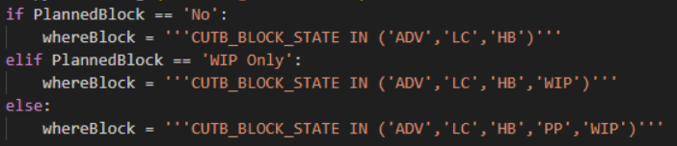
- Determine if you want to add planned blocks not yet in LRM. These will be merged with the other LRM cutblocks

Outputs

This tool outputs:

- One spreadsheet summarizing the watershed area, disturbed area, ECA area (factoring in the years since disturbance and recovery which has taken place) and the total ECA percent. This can be divided by sub-basins and will be exported to parent file to the working geodatabase.

- Spatial outputs:
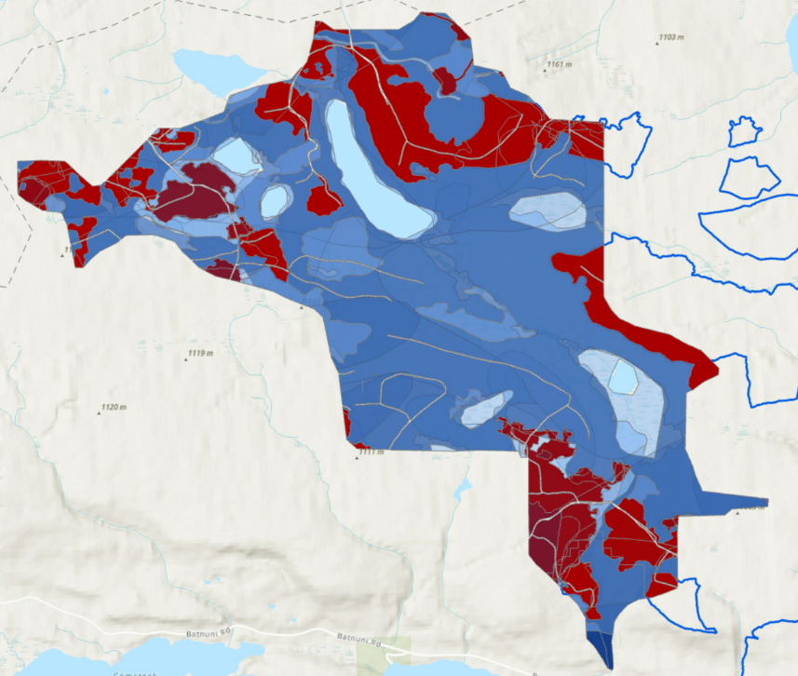
Merged ECA is the main spatial output. Use the symbology in the Merged_ECA.lyrx at the root of the ECA tool folder to symbolize your watershed disturbance.

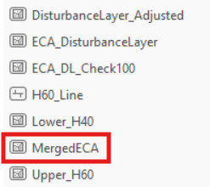
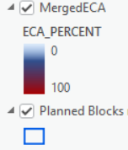

Document Change tracking

Version | Date of Issue | Author(s) | Brief Description of Change
2.0 | Feb 18 2026 | Jennifer Marr | - Document creation for revised ECA tool

